**ONLINE PLATFORM FOR DESSERT PRODUCTS**

**A PROJECT REPORT**

**Submitted by**

**ANGAPPAN N**

**(REG.NO:22BIR003)**

**GOKULA SHANKAR T K**

**(REG.NO:22BIR011)**

**PAVISH K**

**(REG.NO:22BIR036)**

***In partial fulfilment of the requirements***

***for award of the degree of***

**BACHELOR OF SCIENCE**

**IN**

**INFORMATION SYSTEMS**

**DEPARTMENT OF COMPUTER TECHNOLOGY – UG**

**KONGU ENGINEERING COLLEGE**

**(Autonomous)**

**PERUNDURAI, ERODE – 638 060**



**MARCH 2025**

**DEPARTMENT OF COMPUTER TECHNOLOGY – UG**

**KONGU ENGINEERING COLLEGE**

**(Autonomous)**

**PERUNDURAI ERODE – 638060**

**MARCH 2025**

**BONAFIDE CERTIFICATE**

This is to certify that the project report titled “**ONLINE PLATFORM FOR DESSERT PRODUCTS**” is the bonafide record of work done by **ANGAPPAN N (22BIR003), GOKULA SHANKAR T K (22BIR011), PAVISH K (22BIR036)** in partial fulfilment for the award of Degree of Bachelor of Science in **Information Systems** of Anna University Chennai during the year 2024-2025.

**SUPERVISOR HEAD OF THE DEPARTMENT (Signature with seal)**

**Date:**

Submitted for the end semester viva-voice examination held on

**INTERNAL EXAMINER EXTERNAL EXAMINER**

**DEPARTMENT OF COMPUTER TECHNOLOGY – UG**

**KONGU ENGINEERING COLLEGE**

(Autonomous)

**PERUNDURAI ERODE – 638060**

**MARCH 2025**

**DECLARATION**

We affirm that the project titled “**ONLINE PLATFORM FOR DESSERT PRODUCTS”** being submitted in partial fulfilment for the award of **Bachelor of Science in Information Systems** is the original work carried out by us. It has not formed the part of any other project submitted for award of any degree, either in this or any other University.

**ANGAPPAN N** (REG.NO:22BIR003)

**GOKULA SHANKAR T K**

(REG.NO:22BIR011)

**PAVISH K**

(REG.NO:22BIR036)

**Date:**

I certify that the declaration made above by the candidates is true to the best of my knowledge.

**Date:** Name and Signature of the Supervisor

**ABSTRACT**

The Online Platform for Dessert Products is a digital solution designed to assist a local bakery in expanding its reach and enhancing customer convenience. By providing an intuitive and user-friendly interface, the platform allows customers to seamlessly browse an extensive range of bakery products, check availability, and place either bulk or individual orders. Special offers and discounts are highlighted to attract more customers and drive sales. The integration of secure online payment options ensures safe transactions, while real-time order tracking allows users to monitor their purchases effortlessly. This streamlined ordering process significantly improves customer satisfaction and boosts operational efficiency for the bakery.

Developed using the MEAN stack (MongoDB, Express, Angular, and Node.js), the platform is designed for high performance, scalability, and security. Its inventory management system helps the bakery maintain accurate stock levels, preventing shortages or overstocking. A dedicated customer support system is incorporated, allowing users to raise inquiries or seek assistance regarding their orders, creating a more personalized customer experience. By leveraging modern web technologies, the platform ensures seamless responsiveness across various devices, providing an optimized browsing and purchasing experience on desktops, tablets, and mobile phones.

By adopting this digital transformation, the bakery can strengthen its presence in the online marketplace, catering to a wider audience and increasing sales opportunities. The platform not only simplifies operations but also enhances customer engagement through a well-structured interface and interactive features. With an efficient ordering and management system in place, the bakery can expand its business, improve customer retention, and stay competitive in the rapidly evolving e-commerce sector. This innovative solution empowers the bakery to adapt to changing consumer preferences and establish a strong foothold in the digital economy.

**ACKNOWLEDGEMENT**

We express our sincere thanks to our beloved Correspondent **Thiru.A.K.ILANGO BCom., MBA., LLB.,** and other philanthropic trust members of the Kongu Vellalar Institute of Technology Trust for having provided with necessary resources to complete this project.

We are always grateful to our beloved visionary Principal **Dr.V.BALUSAMY B.E., (Hons) MTech., Ph.D.,** and thank him for his motivation and moral support.

We express our deep sense of grati tude and profound thanks to **Dr.S.KALAISELVI MCA., ME., Ph.D.,** Head of the Department, Computer Technology-UG for her invaluable commitment and guidance for this project.

We are in immense pleasure to express our hearty thanks to our beloved Project coordinator **D.NANTHIYA BE., ME.,** and our guide **Dr.A.MUTHUSAMY MCA., Ph.D.,** for providing valuable guidance and constant support throughout the course of our project. We also thank the teaching, non-teaching staff members, fellow students and our parents who stood with us to complete our project successfully.

**TABLE OF CONTENTS**

|  |  |  |  |
| --- | --- | --- | --- |
| **CHAPTER TITLE**  **No.** | | | **PAGE**  **No.** |
|  | | **ABSTRACT** | **iv** |
|  | | **LIST OF FIGURES** | **viii** |
|  | | **LIST OF TABLES** | **ix** |
|  | | **LIST OF ABBREVATIONS** | **x** |
| **1** | | **INTRODUCTION** | **1** |
|  | | 1.1 OVERVIEW OF THE PROJECT | 1 |
|  | | 1.2 PROBLEM DEFINITION | 1 |
|  | | 1.3 OBJECTIVE OF THE PROJECT | 2 |
| **2** | | **SYSTEM ANALYSIS** | **3** |
|  | | 2.1 EXISTING SYSTEM | 3 |
|  | | 2.1.1 Disadvantages of Existing system | 3 |
|  | | 2.2 PROPOSED SYSTEM | 4 |
|  | | 2.2.1 Advantages of Proposed system | 4 |
|  | | 2.3 FEASIBILITY STUDY | 4 |
|  | | 2.3.1 Technical Feasibility | 5 |
|  | | 2.3.2 Operational Feasibility | 5 |
|  | | 2.3.3 Economic Feasibility | 6 |
| **3** | | **SYSTEM SPECIFICATION** | **7** |
|  | | 3.1 HARDWARE SPECIFICATION | 7 |
|  | | 3.2 SOFTWARE SPECIFICATION | 7 |
|  | | 3.2.1 Front End | 7 |
|  | | 3.2.2 Back End | 9 |
| 4 | | **SYSTEM DESCRIPTION** | **11** |
|  | 4.1 MODULE DESCRIPTION | | 11 |
|  | 4.1.1 User Management Module | | 11 |
|  | 4.1.2 Cart Module | | 11 |
|  | 4.1.3 Product Module | | 12 |
|  | 4.1.4 Review Module | | 12 |
|  | 4.1.5 Payment Module | | 12 |
|  | 4.1.6 Order Module | | 12 |
|  | 4.1.7 Admin Module | | 13 |
|  | 4.2 USE CASE DIAGRAM | | 13 |
|  | 4.3 SYSTEM FLOW DIAGRAM | | 14 |
|  | 4.4 DATA FLOW DIAGRAM | | 15 |
|  | 4.5 DATABASE DESIGN | | 16 |
|  | 4.6 INPUT DESIGN | | 20 |
|  | 4.7 OUTPUT DESIGN | | 21 |
| **5** | **SYSTEM TESTING** | | **23** |
|  | 5.1 UNIT TESTING | | 23 |
|  | 5.2 INTEGRATION TESTING | | 24 |
|  | 5.3 VALIDATION TESTING | | 24 |
| **6** | **SYSTEM IMPLEMENTATION** | | **25** |
| **7** | **CONCLUSION & FUTURE ENHANCEMENTS** | | **27** |
|  | 7.1 CONCLUSION | | 27 |
|  | **REFERENCES** | | **28** |
|  | **APPENDIX 1- SAMPLE CODING** | | **29** |
|  | **APPENDIX 2- SCREEN SHOTS** | | **39** |

**LISTS OF FIGURES**

**FIGURE No. TITLE PAGE No.**

4.1 Use case diagram 13

4.2 System flow diagram 14

4.3.1 Data flow diagram level 0 15

4.3.2 Data flow diagram level 1 15

A 2.1 User Management Page 39

A 2.2 Product Page 39

A 2.3 Cart Page 40

A 2.4 Home Page 40

A 2.5 Review Page 41

A 2.6 Order Page 41

A 2.7 Admin Panel 42

A 2.8 Manage User Page 43

A 2.9 Manage Product Page 43

A 2.10 Manage Orders Page 43

A 2.11 Manage State Page 44

A 2.12 Manage Coupon Page 44

A 2.13 Payment Page 45

**LIST OF TABLES**

**TABLE No. TITLE PAGE No.**

4.6.1 Users-datas 16

4.6.2 Products 16

4.6.3 User-addresses 17

4.6.4 Reviews-datas 18

4.6.5 Cartdatas 19

4.6.6 Delivery-states 20

4.6.7 Coupon-codes 20

4.6.8 Order-datas 21

**LIST OF ABBREVATIONS**

|  |  |
| --- | --- |
| **ABBREVATIONS** | **EXPANSION** |
| **HTML** | Hypertext Markup Language |
| **CSS** | Cascading Style Sheet |
| **JSON** | JavaScript Object Notation |
| **JS** | JavaScript |
| **UPI** | Unified Payments Interface |
| **HTTP** | Hypertext Transfer Protocol |
| **API** | Application programming interface |
| **TS** | Type Script |

**CHAPTER 1**

**INTRODUCTION**

**1.1 OVERVIEW OF THE PROJECT**

The Online Platform for Dessert Products is an innovative web-based solution designed to help a local bakery expand its customer base and streamline the ordering process. Built using the MEAN stack (MongoDB, Express, Angular, and Node.js), the platform provides customers with a convenient way to browse and order a wide variety of bakery products, both for personal and bulk event orders.

The platform features an easy-to-use interface where customers can view detailed product descriptions, check product availability, and explore special promotions. Secure online payment options and real-time order tracking ensure a smooth and reliable customer experience. Additionally, the platform includes an inventory management system that enables the bakery to keep track of stock levels and fulfill orders efficiently.

Incorporating a customer support system further enhances user experience, allowing customers to get quick assistance with any inquiries or issues. By leveraging modern web technologies, the platform is not only fast and secure but also scalable, providing a foundation for future growth. Through this digital transformation, the bakery can cater to a wider audience, improve operational efficiency, and strengthen its presence in the competitive online market, ultimately driving business growth and customer satisfaction.

**1.2 PROBLEM DEFINITION**

The local bakery faces challenges in reaching a wider audience and efficiently managing customer orders. With the growing demand for convenience and online shopping, customers increasingly prefer to place orders digitally. The bakery's traditional in-store ordering system limits its ability to handle bulk orders, track inventory, and offer a seamless customer experience. Additionally, customers often face difficulties in accessing product availability information, tracking.

The bakery also struggles with maintaining accurate stock levels and providing timely responses to customer inquiries, leading to potential dissatisfaction and missed business opportunities. Without an online presence, the bakery risks losing customers to competitors offering more accessible and convenient platforms for placing orders.

This project aims to address these challenges by developing a robust and scalable online platform that allows customers to easily browse products, place orders, make secure payments, track orders in real-time, and communicate with customer support. The system will also streamline inventory management for the bakery, helping to improve operational efficiency and enhance customer satisfaction.

**1.3 OBJECTIVE OF THE PROJECT**

The main objective of the Online Platform for Dessert Products is to provide an easy and accessible way for customers to browse and order bakery products online. This includes allowing customers to place individual or bulk orders, view detailed product information, check availability, and explore special offers, all while ensuring secure online payments and real-time order tracking. The platform aims to improve the customer experience by offering a user-friendly interface that works seamlessly across devices and provides efficient support through an integrated customer service system.

Another key objective is to enhance the bakery’s operational efficiency by implementing real-time inventory management and automated order processing systems. This will allow the bakery to manage stock levels, fulfill orders promptly, and ensure smooth order fulfillment. The platform is built to be fast, secure, and scalable, supporting future growth and providing a foundation for the bakery to expand its online presence. By leveraging these features, the project aims to help the bakery reach a larger audience, drive sales, and ultimately contribute to business growth.

**CHAPTER 2**

## SYSTEM ANALYSIS

**2.1 EXISTING SYSTEM**

The existing system at the bakery relies on traditional in-store ordering, where customers visit the bakery to place orders, either for personal or bulk purchases. This manual process can lead to long waiting times and inefficiencies, particularly for bulk orders. There is no digital platform to facilitate online orders, check product availability, or track orders in real time. Inventory management is handled manually, leading to potential errors and delays in fulfilling orders. Customer support is limited to in-person or phone inquiries, which can be inefficient. This system restricts the bakery's growth, limiting its ability to reach a wider audience and meet modern customer expectations.

**2.1.1 DISADVANTAGES OF EXISTING SYSTEM**

## The existing system has following disadvantages.

## Limited accessibility as customers must visit the bakery in person to place orders.

## Inefficiency in order processing, leading to longer waiting times and potential errors.

## No real-time order tracking, causing uncertainty for customers.

## Manual inventory management increases the risk of stock discrepancies and delays.

## Limited customer support available only in person or via phone.

## Lack of an online presence, restricting the bakery’s ability to reach a larger audience.

## Scalability issues, unable to handle increased order volume or demand.

**2.2 PROPOSED SYSTEM**

The proposed system is a web-based Online Platform for DessertProducts, designed to streamline the bakery's ordering process and enhance customer experience. The platform will enable customers to browse and order bakery products online, either for personal or bulk orders, from the comfort of their homes. It will include features like detailed product information, availability checks, special offers, secure payment options, and real-time order tracking, providing a seamless shopping experience.

The system will incorporate an automated inventory management feature to keep track of stock levels in real-time, ensuring accurate product availability and timely order fulfillment. Customer support will be integrated into the platform, offering prompt assistance through live chat or email, improving overall customer satisfaction. Built using the MEAN stack (MongoDB, Express, Angular, Node.js), the platform will be fast, secure, and scalable, supporting future growth. This digital solution will allow the bakery to reach a broader audience, improve order efficiency, and ultimately contribute to business growth by attracting more customers and offering a convenient online shopping experience.

**2.2.1 ADVANTAGES OF PROPOSED SYSTEM**

* The booking process for courses is streamlined and user-friendly, making it easy for clients to enroll online.
* The user interface is intuitively designed, enhancing navigation and accessibility for users.
* Administrators can easily update course information and schedules, ensuring clients have the latest details.
* The system includes dynamic features that allow for quick updates and changes in response to market demands.
* Information is presented dynamically, reducing confusion and improving clarity for clients.

**2.3 FEASIBILITY STUDY**

Feasibility studies are essential for assessing the proposed system's functions, its potential impact on the organization, the ability to meet user requirements, and how effectively resources will be used. While any project can be considered feasible with unlimited resources and time, it is important to evaluate the practicality and associated risks of software development. The proposed system for the Software Training Centre will go through a proof-of-concept phase to establish its viability before moving forward with full development. Understanding the relationship between feasibility and risk is crucial, especially when project risks are high and development feasibility is uncertain.

* + Technical Feasibility
  + Operational Feasibility
  + Economic Feasibility

**2.3.1 TECHNICAL FEASIBILITY**

Technical feasibility examines whether the necessary technology and resources are available for the successful development and implementation of the new system. This stage can be challenging, as the processes of analysis and definition must occur concurrently with the assessment of technical feasibility. A key factor to consider is whether the organization has sufficient resources for both development and implementation. Additionally, the availability of skilled personnel to operate and maintain the system is crucial to ensuring long-term success. Another important aspect is the system's ability to integrate with existing infrastructure without causing disruptions. Given that the proposed system requires minimal resources and leverages existing technologies, it is classified as technically feasible.

**2.3.2 OPERATIONAL FEASIBILITY**

Operational feasibility evaluates whether the system effectively meets the needs of both customers and administrators. The proposed system is designed to provide robust support to users while enhancing overall operational performance. If it successfully fulfills these criteria, it can be regarded as operationally feasible. The system aims to deliver a convenient, user-friendly experience accessible to customers worldwide, thus expanding its reach. Moreover, by creating better market opportunities for service providers, the proposed system further reinforces its operational viability..

**2.3.3 ECONOMICAL FEASIBILITY**

Economic feasibility assesses the project's development costs in relation to the potential revenue and benefits it will generate. The proposed project is advantageous because it does not require any additional hardware or software investments, ensuring its financial viability for the organization. By carefully analyzing costs against expected returns, the project demonstrates strong economic rationale, ensuring that the investment will lead to positive financial outcomes for the Software Training Centre. This thorough assessment of economic feasibility underscores the project's capacity to deliver value and sustainability.

**CHAPTER 3**

**SYSTEM SPECIFICATION**

**3.1 HARDWARE SPECIFICATION**

* Processor : Intel® Core™ i5- 2.00GHz
* Ram : 8GB
* System type : 64-bit operating system
* Hard disk : 512GB
* Keyboard : Standard 102

**3.2 SOFTWARE SPECIFICATION**

* + - Operating System : Windows
    - Front End : HTML, TAILWIND CSS, ANGULAR JS
    - Back End : NODE JS, MONGO DB, EXPRESS JS
    - Environment : Visual Studio, Chrome

**3.2.1 FRONT END**

* **HTML:** Hypertext Markup Language (HTML) is the foundation of the web and a standard for creating webpages. It structures content by organizing text, images, and multimedia. HTML defines elements like headings, paragraphs, and links to create an accessible layout. For the Software Training Centre project, HTML ensures an easy-to-navigate interface for students to access course details and registration forms. The use of semantic HTML helps structure content and improve search engine visibility, contributing to a better user experience. Additionally, HTML's compatibility with modern browsers ensures consistent performance across different platforms and devices.
* **TAILWIND CSS:** Tailwind CSS is a utility-first CSS framework that enables developers to build modern and responsive user interfaces quickly. It provides a set of low-level utility classes that can be combined to style elements directly in the markup, reducing the need for writing custom CSS. Tailwind’s approach promotes consistency and flexibility, allowing developers to create complex designs without leaving the HTML structure. It includes features like responsive design, dark mode, and theming out of the box, with support for customization through a configuration file. Tailwind CSS enhances development speed and maintainability by eliminating the need for writing repetitive CSS and encouraging a more consistent design language across the application.
* **JAVASCRIPT:** JavaScript is a client-side scripting language that enhances the interactivity and functionality of web applications. It allows developers to create dynamic content that can respond to user actions, such as form validation, animations, and real-time updates. JavaScript also enables asynchronous communication with the server through AJAX, allowing data to be fetched and updated without reloading the page. For the Software Training Centre system, JavaScript plays a crucial role in creating interactive features such as course enrollment forms, real-time notifications, and interactive tutorials. External JavaScript files provide better organization and separation of concerns, making the code easier to maintain and debug as the project grows in complexity. Given its versatility, JavaScript enables the system to offer real-time interaction, ensuring that users can access up-to-date course information, schedule notifications, and interact with multimedia learning resources effectively.
* **ANGULAR JS:** AngularJS is a powerful, open-source front-end framework developed by Google, designed fo r building dynamic, single-page applications (SPAs). It extends HTML’s capabilities with features like two-way data binding, which ensures that changes in the data model are automatically reflected in the user interface without manual intervention. AngularJS also offers dependency injection for easier service management, modular architecture for better code organization, and custom directives for creating reusable components. The framework’s built-in tools for routing, testing, and data filtering make it ideal for developing complex, scalable, and maintainable web applications, such as the Online Platform for Dessert Products, providing a seamless user experience and efficient data management.
* **TYPESCRIPT:** TypeScript is a superset of JavaScript that introduces static typing, helping developers catch errors at compile time rather than runtime. It extends JavaScript by adding features such as interfaces, classes, and modules, enabling the development of large-scale applications with better code organization and maintainability. TypeScript improves developer productivity with advanced tooling, including autocompletion, refactoring, and type inference, which makes code easier to navigate and debug. Its compatibility with JavaScript ensures that existing codebases can be gradually migrated, while its strict type-checking reduces bugs and enhances overall application stability. TypeScript also supports modern JavaScript features, ensuring compatibility with evolving web standards and frameworks like Angular, making it a preferred choice for building scalable and robust web applications.

**3.2.2 BACKEND**

* **MONGO DB:** MongoDB is a highly flexible and scalable NoSQL database system, designed to manage large and complex datasets with ease. Unlike traditional relational databases that rely on predefined schemas and tables, MongoDB stores data in flexible, JSON-like documents, which allow for dynamic and adaptable data structures. This flexibility is especially beneficial for applications like the Software Training Center, where various types of data need to be managed, including student profiles, course details, payment information, and user registrations. MongoDB's document-based approach allows the system to handle unstructured or semi-structured data, making it easier to store and retrieve different kinds of information without the limitations of rigid schemas. This adaptability ensures that the system can evolve over time, accommodating new features and data types without requiring complex database migrations. Furthermore, MongoDB supports horizontal scaling, which enables the platform to grow in terms of both traffic and data storage. As the number of users and the amount of stored data increase, MongoDB can scale across multiple servers, ensuring that the platform remains responsive and efficient even under heavy loads, thus maintaining a smooth user experience.
* **EXPRESS JS :** Express.js is a lightweight and flexible web application framework for Node.js that simplifies the process of building web applications and APIs. It provides a robust set of features for handling HTTP requests, routing, and middleware integration, enabling developers to create scalable and maintainable server-side applications with minimal code. Express follows a minimalist design, allowing developers to extend its functionality using third-party middleware and custom modules. Its event-driven and non-blocking architecture ensures high performance, making it suitable for real-time applications. Express’s straightforward routing mechanism and middleware support enable efficient request processing and error handling, improving the overall development experience and application performance.
* **NODE JS:** Node.js, on the other hand, serves as a powerful server-side runtime environment, enabling JavaScript to be executed outside the browser. It has gained widespread popularity for building scalable, high-performance web applications, particularly due to its non-blocking, event-driven architecture. For the Software Training Center project, Node.js acts as the backbone of the server-side operations, handling incoming requests from users, processing those requests, and interfacing with the database to deliver responses. This real-time processing capability is essential for the training platform, where multiple users might be accessing courses, booking sessions, submitting assignments, or interacting with the system at the same time. Node.js excels at managing concurrent connections without becoming a bottleneck, thanks to its event-driven nature, which allows it to handle numerous requests simultaneously without blocking the execution of other tasks. This makes it particularly suitable for real-time applications, ensuring that users experience fast and efficient service regardless of the platform's load. Additionally, its vast ecosystem of modules and packages allows developers to build feature-rich applications quickly and effectively, contributing to the overall scalability and performance of the Software Training Center platform.

**CHAPTER 4**

## SYSTEM DESCRIPTION

**4.1 MODULE DESCRIPTION**

The project contains the following modules such as:

* User Management module
* Cart Module
* Product Module
* Review Module
* Payment Module
* Order Module
* Admin Module

**4.1.1 USER MANAGEMENT MODULE**

The User Management Module allows users to manage their account details and settings efficiently. The login module enables users to log in by entering their username and password, ensuring security through encrypted storage and validation of credentials. The registration module requires users to provide a username, email, password, and confirmation password (cpassword) to create an account securely. Users can edit their profile details, such as updating their username, email, and password, and upload a profile picture. The module also includes an address management feature, allowing users to add, update, and delete delivery addresses. Additionally, it manages user sessions to maintain secure and consistent access, automatically logging out inactive users to enhance security.

**4.1.2 CART MODULE**

This module allows users to update their personal details such as username, email, and password. Users can modify their profile information at any time, including uploading a profile picture. The module also provides an option to change security settings like the password, ensuring users can maintain the security of their accounts. Profile changes are subject to authentication checks for user safety. The module ensures that any sensitive data is encrypted, protecting user information from unauthorized access.

**4.1.3 PRODUCT MODULE**

This module focuses solely on displaying the products offered by the training center. Each product is accompanied by detailed descriptions, including features, pricing, and any applicable promotions. Users can view images, product specifications, and related details, but there is no option for online purchase in this module. The system may provide guidance on how to obtain the products physically or via inquiry.

**4.1.4 REVIEW MODULE**

The contact module provides users with the means to reach the in-charge of the training center directly. Users can fill out a form to submit inquiries, feedback, or requests, which will be sent to the in-charge for review. Essential contact details, such as the in-charge's phone number and email address, may also be provided for direct communication. This module ensures that user concerns and questions are addressed promptly by the appropriate personnel.

**4.1.5 PAYMENT MODULE**

This module handles payments for services and courses through UPI QR codes or cash. For UPI, users can scan a QR code using their mobile phone to complete the payment process, or deep linking can be provided for direct payments on a laptop. There is no support for other payment methods such as credit or debit cards. The system confirms payments and sends receipts to users after successful transactions.

**4.1.6 ORDER MODULE**

The Order Module allows customers to place and manage their orders efficiently. Customers can track order status in real-time and view their order history. The module supports secure payment processing and updates inventory automatically upon order completion. It also provides options for order cancellation and return requests.

**4.1.7 ADMIN**

The admin module enables administrators to manage and monitor all aspects of the platform. Admins can view and manage user accounts, update course details, and manage product listings. They also have the ability to track payment records, ensuring transactions through UPI or cash are logged. Additionally, admins can edit or remove content, ensuring that the system stays up to date with accurate information on products and courses.

**4.2 USE CASE DIAGRAM**

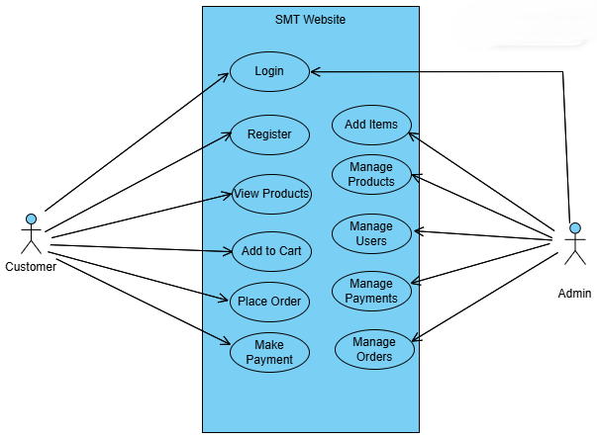

**Figure 4.1 Use Case Diagram**

## 4.3 SYSTEM FLOW DIAGRAM

## 

**Figure 4.2 System Flow Diagram**

**Figure 4.2 System Flow Diagram**

## 4.4 DATA FLOW DIAGRAM

## 4.4.1 DATA FLOW DIAGRAM LEVEL 0

## 

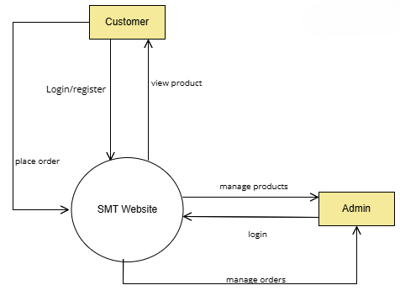**Figure 4.3.1 Data Flow Diagram Level 0**

## 4.4.2 DATA FLOW DIAGRAM LEVEL 1

## 

## 

**Figure 4.3.2 Data Flow Diagram Level 1**

**4.5 DATABASE DESIGN**

TABLE NO : 4.6.1

TABLE NAME : user-datas

DESCRIPTION : The table is used to store the login details of admin and the customers.

|  |  |  |
| --- | --- | --- |
| **FIELD NAME** | **DATA TYPE** | **DESCRIPTION** |
| _id | Object | ObjectId |
| name | String | User Name |
| email | String | User Email |
| Phno | Number | Phone number |
| fullname | String | User Full Name |
| role | String | User Role |
| password | String | User Password |
| pin_code | Number | PIN Code |
| country | String | User Country |
| createdAt | Date | Account Creation Date |
| updatedAt | Date | Account Updation Date |

TABLE NO : 4.6.2

TABLE NAME : products

DESCRIPTION : The table is used to store the products details.

|  |  |  |
| --- | --- | --- |
| **FIELD NAME** | **DATA TYPE** | **DESCRIPTION** |
| _id | Object | ObjectId |
| name | String | Product name |
| src | String | Product Image Path |
| type | String | Product Tyoe |
| desc | String | Product description |
| price | Number | Product Price |
| rating | Number | Product Rating |
| **FIELD NAME** | **DATA TYPE** | **DESCRIPTION** |
| isVeg | Boolean | Specification |
| minquantity | Number | Product Minimum Quantity |
| pieces | Number | Product Pieces in Box |
| maxquantity | Number | Product Maximum Quantity |
| stock_quantity | Number | Product Quantity |

TABLE NO : 4.6.3

TABLE NAME : user-addresses

DESCRIPTION : The table is used to store the user address details.

|  |  |  |
| --- | --- | --- |
| **FIELD NAME** | **DATA TYPE** | **DESCRIPTION** |
| _id | Object | ObjectId |
| userId | Object | User ObjectId |
| fullname | String | User Fullname |
| phoneNumber | Number | User Phone Number |
| pinCode | Number | User Current PIN Code |
| houseNo | String | User House Name/Number |
| roadNo | String | User Road Name/Number |
| state | String | User Current State |
| city | String | User City |
| address | String | User Current Address |
| createdAt | Date | Address Creation Time |
| updatedAt | Date | Address Updation Time |

TABLE NO : 4.6.4

TABLE NAME : reviews-datas

DESCRIPTION : The table is used to store the user review details.

|  |  |  |
| --- | --- | --- |
| **FIELD NAME** | **DATA TYPE** | **DESCRIPTION** |
| _id | Object | ObjectId |
| userId | Object | User ObjectId |
| name | String | User Name |
| rating | Number | User Product Rating |
| comment | String | User Product Comments |
| image | String | User Product Image Path |
| date | Date | User Review Creation Date |

TABLE NO : 4.6.5

TABLE NAME : cartdatas

DESCRIPTION : The table is used to store the user cart details.

|  |  |  |
| --- | --- | --- |
| **FIELD NAME** | **DATA TYPE** | **DESCRIPTION** |
| _id | Object | ObjectId |
| userId | Object | User ObjectId |
| productId | Object | Product Object Id |
| productName | String | Product Name |
| quantity | Number | Product Quantity |
| price | Number | Product Price |
| totalPrice | Number | Products Total Price |
| imgSrc | String | Product Image Path |
| stock_quantity | Number | Product Stock Quantity |
| product_is_veg | Boolean | Product Specification |
| product_type | String | Product Type |
| max_quantity | Number | Product Maximum Quantity |
| min_quantity | Number | Product Minimum Quantity |
| pack_quantity | Number | Product Pieces In Box |
| createdAt | Date | Cart Creation Time |
| updatedAt | Date | Cart Updation Time |

TABLE NO : 4.6.6

TABLE NAME : delivery-states

DESCRIPTION : The table is used to store the delivery details.

|  |  |  |
| --- | --- | --- |
| **FIELD NAME** | **DATA TYPE** | **DESCRIPTION** |
| _id | Object | ObjectId |
| city | String | City Name |
| state | String | State Name |
| charge | Number | Shipping Charge |
| isAvailable | Boolean | Shipping Available |

TABLE NO : 4.6.7

TABLE NAME : coupon-codes

DESCRIPTION : The table is used to store the coupon details.

|  |  |  |
| --- | --- | --- |
| **FIELD NAME** | **DATA TYPE** | **DESCRIPTION** |
| _id | Object | ObjectId |
| coupon_code | String | Coupon Code |
| exp_date | Date | Coupon Code Expiry Date |
| used_userIDs | Array | Used Code User ObjectId |
| max_use | Number | Maximum Usage |

TABLE NO : 4.6.8

TABLE NAME : order-datas

DESCRIPTION : The table is used to store the order details.

|  |  |  |
| --- | --- | --- |
| **FIELD NAME** | **DATA TYPE** | **DESCRIPTION** |
| _id | Object | ObjectId |
| userId | Object | User ID |
| tems | Array | List of ordered items |
| totalAmount | Number | Total order amount |
| status | String | Order status |
| createdAt | Date | Order creation date |
| updatedAt | Date | |  | | --- | |  |  |  | | --- | | Last update timestamp | |

**4.6 INPUT DESIGN**

In the proposed work, several key input forms have been designed to enhance the user experience and ensure smooth interaction with the bakery platform. These forms include the Customer Registration Form and the Product Details Form. The Customer Registration Form captures essential information such as First Name, Last Name, Email ID, and Password. It incorporates validation checks for critical fields like password strength and mobile number formatting, ensuring data accuracy and security. If the data entered is invalid, appropriate error messages are displayed to guide the user in correcting their input. The input design features the Login Form, Register Form, Edit Profile Form, and Order Form, each tailored to specific user needs.

The Login Form is the entry point for customers to access their accounts. It is designed with simplicity and security in mind, requiring a username (or email) and password for authentication. To enhance security, features like password recovery options and two-factor authentication are integrated, ensuring user safety. The form is responsive, adapting to different device sizes and platforms, ensuring a smooth experience for users on both mobile and desktop. Additionally, clear and concise error messages are presented when incorrect information is entered, helping users quickly resolve login issues.

The Register Form facilitates the creation of new customer accounts. It collects vital information, such as the customer's name, email address, and password, with a focus on maintaining high levels of security through measures like email verification and strong password requirements. The form’s design is intuitive and user-friendly, guiding users step-by-step through the registration process. Options for social media logins can also be provided to simplify account creation. By clearly presenting terms of service and privacy policies, the form builds trust with users, increasing the likelihood of successful registrations and long-term engagement.

The Edit Profile Form allows customers to update their personal information securely and efficiently. It is designed to pre-fill existing customer data, enabling quick and easy modifications. Security is a priority, with password re-entry required for significant changes such as email or password updates, preventing unauthorized alterations. Validation messages ensure that all data entered is accurate, and clear instructions help users understand the steps involved. The design emphasizes ease of use, ensuring that even less tech-savvy users can comfortably update their profiles.

The Order Form allows customers to place orders for bakery products quickly and efficiently. It captures essential details like the product name, quantity, delivery address, and payment method. Dropdown menus and checkboxes simplify the selection process, and a summary of the order, including total cost and delivery time, is provided before submission. Immediate confirmation upon submission reassures customers that their order is successful, and clear next steps, such as order tracking, are provided. The form is designed with a clean and organized layout, enhancing usability and making the ordering process straightforward and engaging for users, regardless of their technical expertise.

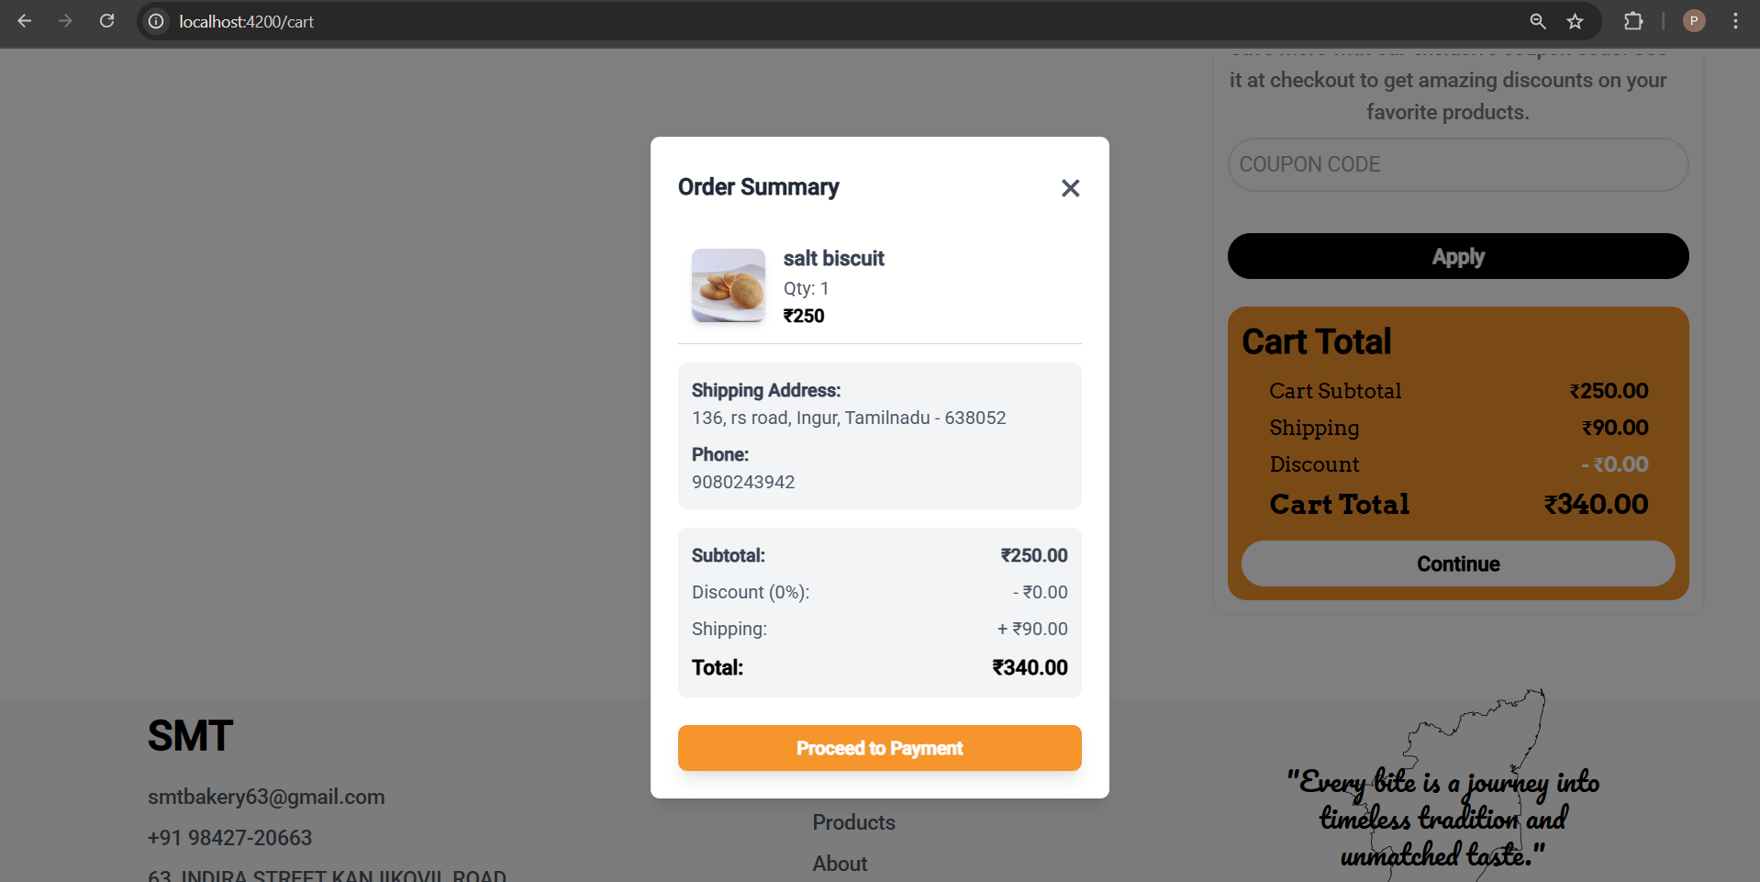

**Figure 4.4 Checkout Page**

**4.7 OUTPUT DESIGN**

The output in this project focuses on delivering critical information to customers in a clear and understandable manner, with the primary output being the Order Summary section, which provides detailed information about the products customers have ordered. This section enables customers to efficiently manage their orders and payments by displaying key details such as Product Name, Quantity, Payment Type, and Total Cost. The output design includes a flexible Payment Module supporting both online and offline methods. For online orders, customers are guided through a seamless payment process with clear instructions, while for offline orders, customers can make cash payments upon delivery or use a QR code for quick digital payments, ensuring convenience for all users.

The information displayed in the Order Summary section helps customers keep track of their orders and payments, ensuring transparency and clarity in the financial aspect of their purchases. This organized and user-friendly design enhances the overall customer experience, allowing for easy reference and management of ongoing and completed orders. The goal is to deliver output that is both efficient and accessible, ensuring customers can interact with the system smoothly and confidently.

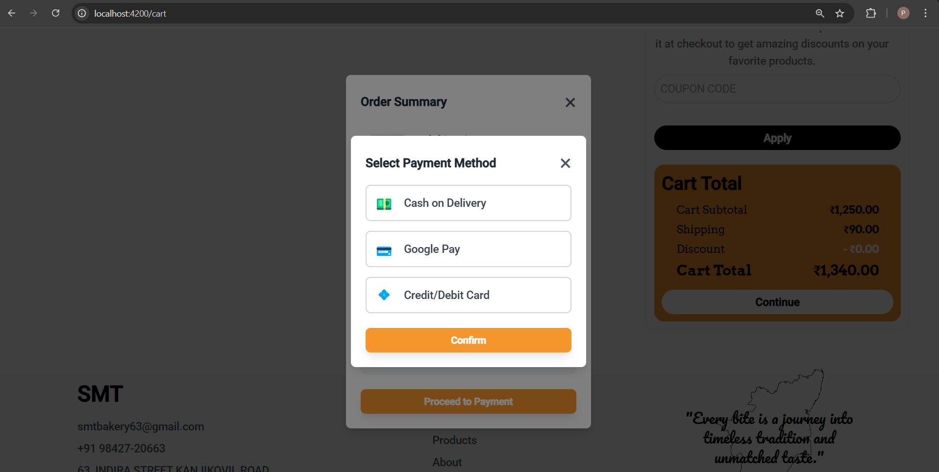

**Figure 4.5 Payment Page**

**CHAPTER 5**

**SYSTEM TESTING**

System testing is a type of testing that evaluates the overall functionality and performance of a complete and fully integrated software. System testing is performed on a complete integrated system to evaluate the compliance of the system with the corresponding requirements.

**5.1 UNIT TESTING**

In unit testing, we must test the programs making up the system. By giving improper inputs, the errors occurred are noted and eliminated. This enables, to detection of errors in coding and logic that are contained within the module alone. The testing was carried out during the programming. In this system each form is considered as a separate unit and tested for errors. Every user inut is unit tested for a valid accepted range.

Test Case 1

Module : Admin Login

Login Type : Loading of the appropriate form for the administrator

Input : Username and Password

Expected Output : Display admin menu

Sample Test Case

Output : Redirect to the main page and display the admin menus

Analysis : The admin login form validates the username and password. If correct, the system redirects to the main page and displays the admin menu.

**5.2 INTEGRATION TESTING**

Testing is done for each module. After testing all the modules, the modules are integrated and testing of the final system is done with the test data, specially designed to show that the system will operate successfully in all its aspects conditions.

Test Case 1

Module : Admin

Test Type : Product Management and Order Management

Input : Navigation between Admin options

Expected Output : Navigation between modules is completed successfully

Sample Test Case

Output : On Clicking Login and other Admin modules the respective pages will open correctly.

Analysis : Ensures that all admin functionalities navigate to the correct pages without errors.

**5.3 VALIDATION TESTING**

Verification and validation testing are two important tests, which are carried out before the product has been handed over to the customer. It determines whether the software function as the user expected.

**Test Case 1**

Module : Customer Registration

Test Type : Register new user

Input : Input to all required fields

Expected Output : Required fields should not be empty

Sample Test Case

Input : A required field is left empty

Output : Prompt user to provide all required fields.

Analysis : Navigation to the next page is blocked until all required fields are correctly.

**CHAPTER 6**

**SYSTEM IMPLEMENTATION**

System implementation is a critical phase in project development where the theoretical design transforms into a fully operational system. This stage requires meticulous planning and control, as any oversight can lead to significant errors and complications, affecting the system's success and user confidence in its functionality and effectiveness. The implementation process begins with the evaluation of the newly designed or revised system, created by the system analysis team, followed by a demonstration to end users to verify its logical flow and functionality through various combinations of test data. Once both end users and management approve the system, it proceeds to full implementation. Key activities in this stage include several major components essential for converting the design into an operational system.

**CODING**

Coding is the process in which the physical design specifications, created by the analysis team, are transformed into working computer code by the programming team. This stage involves selecting appropriate programming languages and tools that align with the system's requirements. The quality of the code is vital, as it lays the foundation for the system’s functionality and performance.

**TESTING**

Testing begins once the coding process starts and continues in parallel. Each program module is subjected to rigorous testing to ensure it operates as intended. This process includes unit testing, integration testing, and system testing to validate that all components work together harmoniously. Effective testing ensures that a high-quality product is delivered to the customers, minimizing the risk of defects and enhancing user satisfaction.

**INSTALLATION**

Installation is the process of replacing the current system with the new one. This includes converting existing data, updating software, and aligning documentation and work procedures with the new system. Careful planning is essential during installation to ensure a seamless transition, minimizing disruptions to daily operations and ensuring that users can adapt to the new system effectively.

**DOCUMENTATION**

Documentation emerges from the installation process and includes user guides that provide comprehensive information on how to operate the system and its flow. This documentation serves as a vital resource for users, helping them understand the system's functionalities, troubleshooting common issues, and facilitating smoother onboarding for new users.

**TRAINING AND SUPPORT**

A well-developed training plan is essential to equip users with the knowledge and skills needed to navigate the new system effectively. The training strategy likely begins in the earlier stages of the project, ensuring that users can quickly acclimate to the system. Ongoing support is also critical, providing users with assistance and resources as they adapt to the changes, ultimately contributing to the system's overall success and user satisfaction.

**CHAPTER 7**

**CONCLUSION AND FUTURE ENHANCEMENTS**

**7.1 CONCLUSION**

In conclusion, implementing the **Online Platform for Dessert Products** is a crucial step that transforms design ideas into real solutions that effectively meet customer needs and align with the bakery's business goals. This stage requires careful planning and execution to minimize errors and ensure a smooth transition to a fully operational platform. By thoroughly testing the platform and validating its performance, we can build confidence among customers, ensuring they trust and feel comfortable using the new features. Additionally, providing comprehensive guidance and ongoing support empowers customers to maximize their engagement with the platform and helps them navigate any challenges they may face. A successful implementation not only enhances overall efficiency and customer satisfaction but also establishes a solid foundation for future improvements, allowing the bakery to adapt to evolving customer needs and remain competitive in the market. Ultimately, effective system implementation fosters innovation and positions the bakery for long-term success, ensuring that it can continuously meet the demands of its customers and stakeholders.

**REFERENCES**

[1] **Shama Hoque**, "Learning MEAN Stack Development: Build web applications with MongoDB, Express.js, Angular, and Node.js," Packt Publishing, Second Edition, 2020.

[2] **Simon Holmes & Clive Harber,** "Getting MEAN with Mongo, Express, Angular, and Node," Manning Publications, Second Edition, 2019.

[3] **Amos Q. Haviv**, "MEAN Web Development," Packt Publishing, Second Edition, 2016.

[4] **Vasan Subramanian**, "Pro MEAN Stack Development," Apress, First Edition, 2017.

[5] **Valentin Bojinov**, "Angular for Enterprise-Ready Web Applications," Packt Publishing, Second Edition, 2020.

**WEBSITES**

[1] MEAN Stack Official Documentation: <https://mean.io>

[2] MongoDB Official Documentation: <https://www.mongodb.com/docs/manual/>

[3] Express.js Guide: <https://expressjs.com/>

[4] Angular Developer Guide: <https://angular.io/doc>

[5] Node.js Official Website: <https://nodejs.org/>

[6] Tutorials and Community Discussions: <https://stackoverflow.com/>

**APPENDIX 1- SAMPLE CODING**

**HOME**

<div class="ml-24 mr-24 mt-28 mobile_nav:ml-5 mobile_nav:mr-5 mobile_nav:mt-24">

  <div class="flex items-center justify-evenly mobile_nav:flex-col ">

    <div class="w-landing_img mobile_nav:w-auto ">

      <h1 class="text-7xl font-arvo font-semibold text-h-t-color mobile_nav:text-5xl">Sri Murugan<br>Biscuits</h1>

      <p class="font-medium text-lg mt-6 break-words text-justify">At Sri Murugan Biscuit Bakery, our biscuits are crafted to be enjoyed at any time of the day. Designed to suit all climates, they retain their delightful taste and crunch wherever you are. Made with a blend of natural and artificial ingredients, every bite delivers the perfect balance of flavor and freshness!</p>

      <button class="bg-black h-14 w-52 text-white text-lg mt-6 rounded-lg text-center font-medium transition ease-linear delay-100 hover:scale-105" routerLink="/about">View More</button>

    </div>

    <div class="w-landing_img mobile_nav:w-auto mobile_nav:h-auto">

      <img class="w-auto h-auto"

      src="decoration/landing_page_1.jpg"

      srcser="decoration/landing_page_1.jpg 1200w"

      >

    </div>

  </div>

  <div class="flex items-start justify-around mobile_nav:flex-col-reverse mobile_nav:gap-y-2  rounded-xl shadow-lg border-2 border-gray-200 shadow-gray-200 w-auto">

    <div class="w-full rounded-xl p-3 mobile_nav:p-2 self-center mobile_nav:self-stretch">

      <img src="decoration/bakery_items.jpg" class="rounded-2xl w-full">

    </div>

    <div class="flex items-start justify-center flex-col gap-y-4 p-3 mobile_nav:p-2">

      <h1 class="text-4xl font-bold font-arvo text-">Fresh & Flavorful: Real and Carefully Selected Ingredients</h1>

      <p class="text-lg font-medium text-justify">

        Welcome to Sri Murugan Biscuits Bakery, where every treat is crafted with real, carefully selected ingredients. We use the finest flours, rich chocolates, and fresh, locally-sourced produce to deliver pure, wholesome flavors. From cookies to cakes, enjoy delightful treats made with freshness you can taste. Indulge in the perfect blend of tradition and quality in every bite.

      </p>

      <button class="bg-black h-14 w-52 text-white text-lg mt-0 rounded-lg text-center font-medium transition ease-linear delay-100 hover:scale-105" routerLink="/products">View Products</button>

    </div>

  </div>

  <div class="p-3 mt-20 flex items-center flex-row justify-between gap-x-5 mobile_nav:flex-col mobile_nav:gap-y-5 mobile_nav:mt-8">

    <div class="flex items-start justify-start gap-y-5 flex-col ">

      <h1 class="text-5xl font-medium mobile_nav:text-4xl">Why Choose Us?</h1>

      <p class="text-lg text-justify font-medium">We deliver freshly baked, handcrafted desserts made with the finest ingredients and care. Our wide range of treats caters to every taste, all at affordable prices. With strict hygiene standards, exceptional customer service, and a convenient online shopping experience, we make every moment sweeter.</p>

      <button class="bg-black h-14 w-52 text-white text-lg mt-0 rounded-lg text-center font-medium transition ease-linear delay-100 hover:scale-105"  routerLink="/reviews">See Reviews</button>

    </div>

    <div class="w-auto">

      <img src="decoration/landing_page_wcu.png" class="w-l_p2 mobile_nav:w-auto mobile_nav:h-auto h-l_p2 object-cover rounded-2xl">

    </div>

    <div class="flex items-center justify-center flex-col gap-y-5 w-full">

      <div class="flex items-center justify-center flex-col gap-y-3 border-4 rounded-2xl border-gray-200 shadow-gray-100 shadow-xl ">

        <img src="icons/coffee.svg" class="w-14 p-2">

        <h1 class="text-xl font-semibold">Perfectly Paired</h1>

        <p class="p-2 text-center">Crafted to complement your coffee, delivering a delightful experience with every bite.</p>

      </div>

      <div class="flex items-center justify-center flex-col gap-y-3 border-4 rounded-2xl border-gray-200 shadow-gray-100 shadow-xl">

        <img src="icons/quality.svg" class="w-14 p-2">

        <h1 class="text-xl font-semibold">Quality Assured</h1>

        <p class="p-2 text-center">Baked daily to provide consistent taste and satisfaction in every bite.</p>

      </div>

    </div>

  </div>

<div class="flex items-center justify-center flex-col mt-20 gap-y-6 mobile_nav:mt-8 p-3">

    <h1 class="capitalize font-semibold text-5xl mobile_nav:text-4xl text-center">our best selling product</h1>

    <p class="text-center text-lg">Discover our best-selling treats – baked fresh and crafted to delight every bite. Your perfect indulgence awaits!</p>

    <div class="flex items-center justify-center flex-row gap-x-0 mobile_nav:flex-col mobile_nav:gap-y-6 mobile_nav:w-auto">

      <div class="flex items-center justify-center flex-col gap-y-2 p-2">

        <img src="items/bread.jpg" class="w-bsp  h-96 mobile_nav:h-60 rounded-2xl object-cover">

        <h2 class="text-2xl font-bold ">Bread</h2>

        <p class="text-center text-lg font-normal">"Soft, fresh bread baked to perfection for every meal."</p>

      </div>

      <div class="flex items-center justify-center flex-col gap-y-2 p-2 mobile_nav:p-0">

        <img src="items/coconut_bun.jpg" class="w-bsp h-96 mobile_nav:h-60 rounded-2xl object-cover">

        <h2 class="text-2xl font-bold">Coconut Bun</h2>

        <p class="text-center text-lg font-normal">"Sweet, soft Coconut Buns with tropical flavor in every bite."</p>

      </div>

      <div class="flex items-center justify-center flex-col gap-y-2 ">

        <img src="items/special_rusk.jpg" class="w-bsp h-96 mobile_nav:h-60 rounded-2xl object-cover">

        <h2 class="text-2xl font-bold">Special Rusk</h2>

        <p class="text-center text-lg font-normal">"Golden, crunchy Special Rusk – perfect for tea time."</p>

      </div>

    </div>

    <button class="bg-black h-14 w-52 text-white text-lg mt-3 rounded-lg text-center font-medium transition ease-linear delay-100 hover:scale-105 mobile_nav:mt-0" routerLink="/products">View More</button>

</div>

<div #counterElement class="bg-black grid justify-around items-center grid-flow-col text-white p-3 rounded-3xl mt-8 mobile_nav:grid-flow-row mobile_nav:gap-y-6 gap-1">

  <div class="text-center flex items-center justify-center gap-1 flex-col">

    <h1 class="text-4xl font-normal">{{Counter.value1}}%</h1>

    <hr class="w-full bg-h-t-color h-1">

    <p>Customer Satisfaction</p>

  </div>

  <div class="text-center flex items-center justify-center gap-1 flex-col ">

    <h1 class="text-4xl font-normal">{{Counter.value2}}+</h1>

    <hr class="w-full bg-h-t-color h-1">

    <p>Supply Over TamilNadu</p>

  </div>

  <div class="text-center flex items-center justify-center gap-1 flex-col">

    <h1 class="text-4xl font-normal">{{Counter.value3}}+</h1>

    <hr class="w-full bg-h-t-color h-1">

    <p>Supply to Other States</p>

  </div>

</div>

<div class="flex items-center justify-center flex-col gap-y-10 mt-20 mobile_nav:mt-8 mobile_nav:gap-y-3 p-1 w-full">

  <h1 class="capitalize font-semibold text-5xl mobile_nav:text-4xl text-center">contact us</h1>

  <div class="flex items-center justify-center flex-row mobile_nav:mt-6">

    <form class="flex items-start justify-start flex-col gap-y-6" #formData="ngForm" (ngSubmit)="contact.handleSubmitBtn(formData)">

      <input type="text" placeholder="Name *" class="text-left w-full p-3 border-black border-2 rounded-xl" name="name" ngModel required>

      <input type="email" placeholder="Email *" class="text-left w-full p-3 border-black border-2 rounded-xl" name="email" ngModel required >

      <textarea placeholder="Message *" class="text-left w-full p-3 border-black border-2 rounded-xl" name="message" ngModel required></textarea>

      <button class="bg-black text-white font-medium text-lg text-center w-full p-2 rounded-xl transition ease-linear delay-100 hover:scale-95">Submit</button>

    </form>

    <div class="">

      <img src="decoration/contact-us.svg" class="w-96 h-l_p2 mobile_nav:hidden">

    </div>

  </div>

</div>

</div>

<app-loading-spinner [isLoading]="contact.makeLoad"></app-loading-spinner>

**PRODUCT**

<!-- Popup State -->

<div *ngIf="popUpState" class="fixed inset-0 flex items-center justify-center bg-black bg-opacity-50 ">

  <div class="bg-white w-96 p-5 rounded-xl shadow-lg mobile_nav">

    <div class="flex justify-between items-center mb-4">

      <h1 class="text-2xl font-semibold">Currently Available States</h1>

      <button class="text-gray-500 hover:text-orange-500 text-2xl" (click)="closeOrOpenStatePopup()">✖</button>

    </div>

    <div  class="max-h-60 overflow-y-auto border rounded p-2">

      <div class="grid grid-cols-2 gap-2">

        <div class="p-2 bg-gray-100 rounded flex justify-between" *ngFor="let country of countryData">

          <span class="capitalize">{{country.name}}</span> <span class="font-semibold">{{country.charge | currency:'INR'}}</span>

        </div>

      </div>

    </div>

    <div class="mt-4 text-right">

      <button class="px-4 py-2 bg-h-t-color text-white rounded hover:bg-orange-600" (click)="closeOrOpenStatePopup()">Close</button>

    </div>

  </div>

</div>

<!-- Description SMT -->

<div  *ngIf="popUpDescription" class="fixed inset-0 flex items-center justify-center bg-black bg-opacity-50" (click)="closeOrOpenDescriptionPopUp()">

  <div id="goToProduct" class="bg-white w-96 p-5 rounded-xl shadow-lg mobile_nav">

    <div class="flex justify-between items-center mb-4">

      <h1 class="text-2xl font-semibold capitalize">description</h1>

      <button class="text-gray-500 hover:text-red-500 text-2xl">✖</button>

    </div>

    <p class="text-gray-600 text-lg text-justify">

      Sri Murugan Biscuit Bakery brings you the perfect blend of tradition and taste with our freshly baked delights. Crafted with the finest ingredients, our biscuits and cakes are a treat for those who appreciate quality and flavor in every bite.

    </p>

  </div>

</div>

<!-- Product Details -->

<div  id="goToProduct" class="flex items-start justify-start gap-x-4 flex-row p-3 mobile_nav:flex-col mobile_nav:gap-y-3 mt-24 mobile_nav:mt-16">

  <div class="flex flex-col items-center justify-center">

    <div class="w-disp_img mobile_nav:w-auto">

      <img class="h-disp_image w-disp_img mobile_nav:w-auto mobile_nav:h-96 p-1 object-cover hover:scale-105 transition ease-linear delay-100 rounded-3xl flex-1" [src]="'http://localhost:8080' + productData.src" >

    </div>

    <div class=" hover:scale-95 transition ease-linear delay-100 flex items-center justify-center flex-row w-full mt-4 gap-x-1 mobile_nav:bottom-0 mobile_nav:fixed mobile_nav:p-1 ">

      <button class="uppercase  h-10 w-full p-8 font-bold text-lg text-white bg-black border-none rounded-md flex items-center justify-center gap-x-1" (click)="onAddToCartBtnClicked()">

        <img class="w-8" src="icons/add-to-cart.svg">

        Add to cart</button>

    </div>

  </div>

  <div class="flex items-start justify-start flex-col gap-y-2 mobile_nav:p-2 p-1">

    <div class="flex items-start justify-start flex-col gap-y-1">

      <h1 class="font-semibold text-4xl mobile_nav:text-3xl capitalize font-arvo">{{productData.name}}</h1>

      <h2 class="text-xl font-normal text-justify">{{productData.desc}}</h2>

      <div class="flex items-center justify-start gap-x-2 mt-1">

        <p class="bg-h-t-color p-1 rounded-lg text-white font-normal text-xl font-pacifico">{{productData.rating}}</p>

        <p [innerHTML]="productData.rating | starRating:5" class="text-3xl"></p>

      </div>

      <p class="font-arvo text-3xl mt-2 font-medium">{{productData.price | currency:'INR'}}</p>

    </div>

    <p class="w-96 font-normal border-2 border-h-t-color bg-orange-50 p-2 rounded-lg mt-1 text-justify flex items-start justify-start gap-x-1 mobile_nav:w-auto">

      <img src="icons/sand-clock.svg" class="w-5 h-5">

      This product has a shelf life of 6 months from the date of manufacture.</p>

      <!-- Other Details -->

       <div class="gap-x-20 mobile_nav:w-full w-disp_product flex flex-col gap-y-4">

      <div class="p-0 mt-5 flex items-center justify-between ">

        <h1 class=" font-medium  text-xl">Delivery Available</h1>

        <p class=" text-blue-600 font-medium text-lg cursor-pointer" (click)="closeOrOpenStatePopup()">View States</p>

    </div>

      <div class="p-0 mt-2 justify-between flex items-center ">

        <h1 class=" font-medium  text-xl">Min Quandity</h1>

        <p class=" font-medium text-lg">{{productData.minquantity}} Boxes</p>

    </div>

      <div class="p-0 mt-2 justify-between flex items-start ">

        <h1 class=" font-medium  text-xl">Highlights</h1>

        <ul class="font-medium text-lg flex flex-col gap-y-1 list-disc">

          <li>Type: {{productData.type}}</li>

          <li>Price per Slice:  {{productData.price|currency:'INR'}}</li>

          <li>{{productData.isVeg=="true"?"Vegetarian":"Non-Vegetarian"}}</li>

        </ul>

    </div>

    <div class="p-0 mt-2 justify-between flex items-center ">

      <h1 class=" font-medium  text-xl">Seller</h1>

      <p class="text-blue-600 font-medium text-lg cursor-pointer" (click)="closeOrOpenDescriptionPopUp()">Sri Murugan Biscuit Bakery</p>

  </div>

  <div class="p-0 mt-2 justify-between flex items-center ">

    <h1 class=" font-medium  text-xl">In The Box</h1>

    <p class=" font-medium text-lg "><span>{{productData.pieces}}</span> Pieces </div>

  </div>

  </div>

  <!-- <div class="p-0 mt-2 justify-between flex items-start gap-x-16">

    <h1 class=" font-medium  text-xl">Description</h1>

    <p class=" font-medium text-lg w-disp_img mobile_nav:w-auto text-justify ">

      Sri Murugan Biscuit Bakery brings you the perfect blend of tradition and taste with our freshly baked delights. Crafted with the finest ingredients, our biscuits and cakes are a treat for those who appreciate quality and flavor in every bite.</p>

</div> -->

</div>

<hr class="border-2 border-gray-300 mt-4 m-3">

<div class="flex items-center justify-center gap-y-4 flex-col p-3 mobile_nav:mt-3">

  <div>

    <h1 class="text-3xl self-start font-medium mobile_nav:font-2xl">You May Also Like</h1>

  </div>

    <div class=" grid grid-cols-4 place-items-center mobile_nav:grid-cols-1 gap-y-5 gap-x-4">

      <div class="border-2  w-fit h-fit rounded-2xl border-items-color shadow-xl shadow-items-color" *ngFor="let product of randomProducts">

        <div class="flex items-start justify-start flex-col" (click)="onClickProduct(product);  this.ScrollIntoElement();">

          <div class="p-2 bg-items-color rounded-2xl">

            <img [src]="'http://localhost:8080' + product.src" class="w-72 h-64 object-cover rounded-2xl hover:scale-105 transition ease-linear delay-75">

          </div>

          <h1 class="text-2xl font-normal capitalize pl-2">{{product.name}}</h1>

          <div class="flex items-center justify-between w-full p-1">

            <p class="float-start text-lg bg-items-color text-orange-700 p-2 rounded-xl" [ngStyle]="{'color':matchColor[product.type] || 'orange'}">{{product.type}}</p>

            <p class="float-end text-3xl p-2 font-medium font-arvo">{{product.price|currency:'INR'}}</p>

          </div>

        </div>

        </div>

  </div>

</div>

<app-loading-spinner [isLoading]="makeLoading"></app-loading-spinner>

**APPENDIX 2 - SCREENSHOTS**

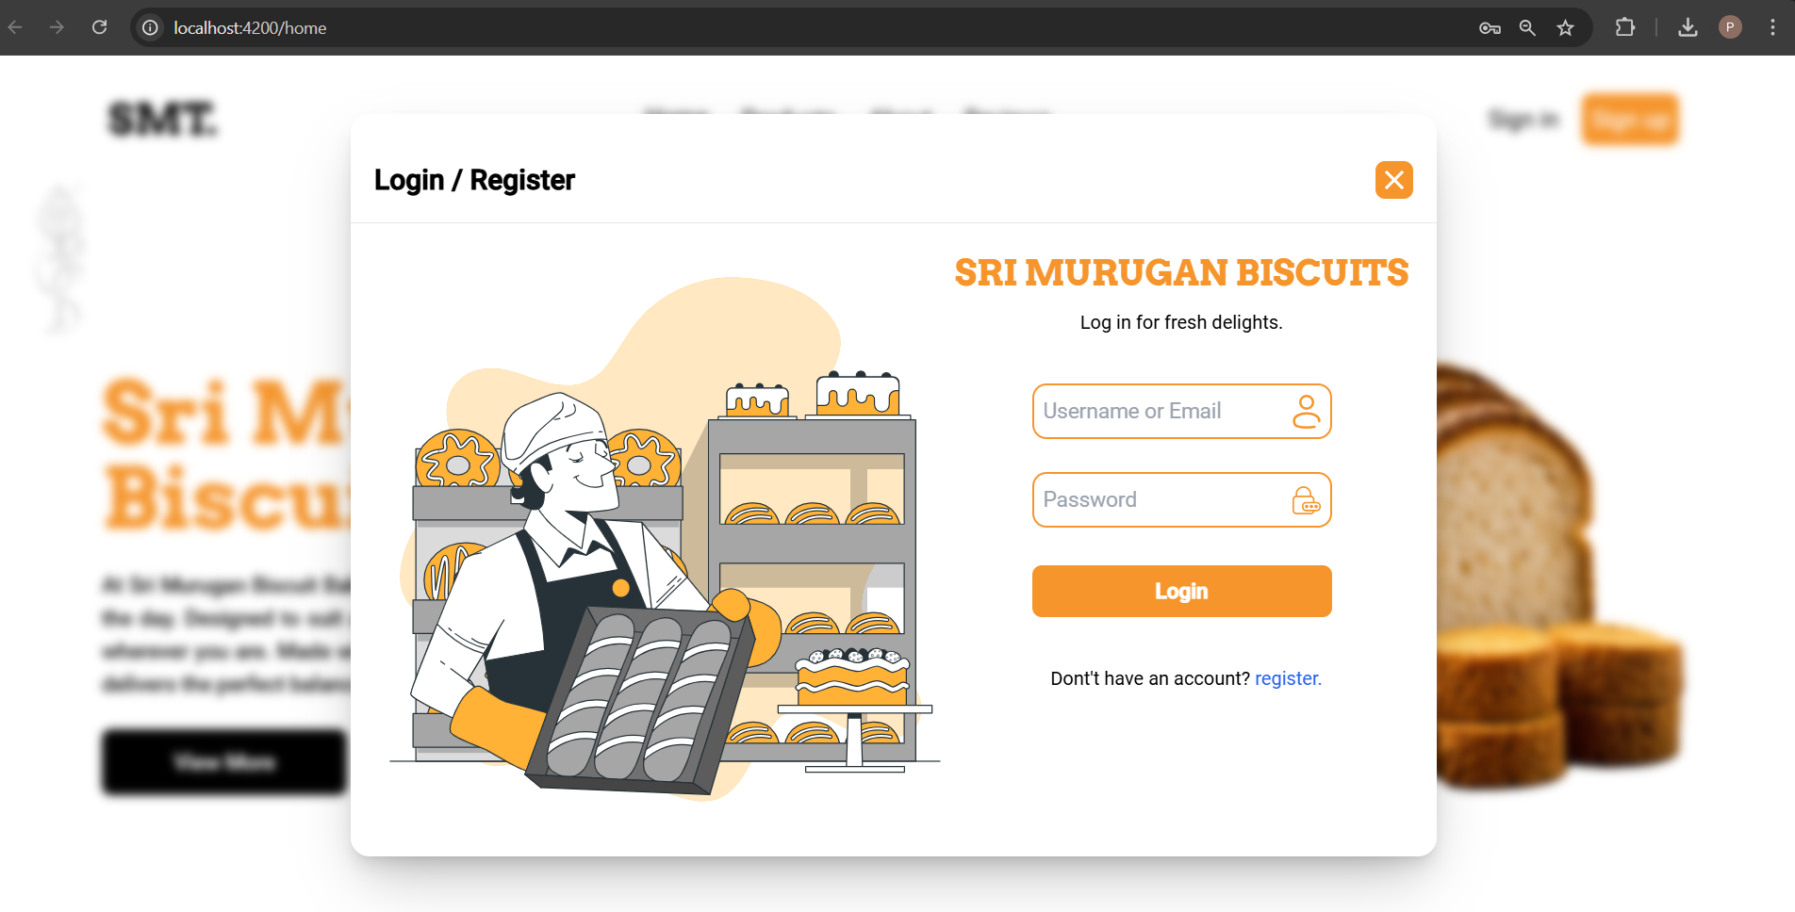 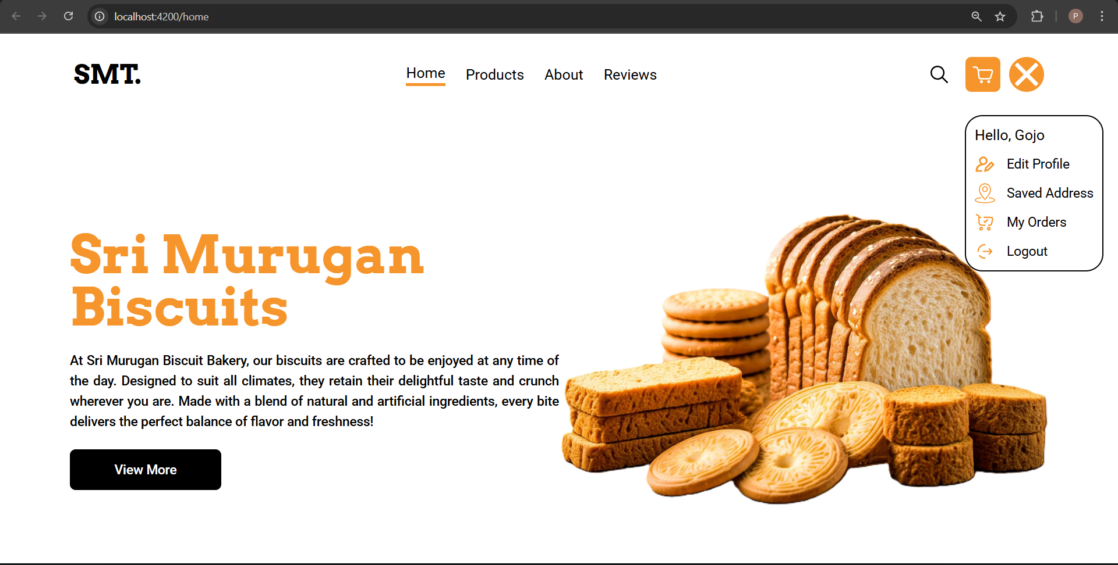

Figure A 2.1 User Management Page

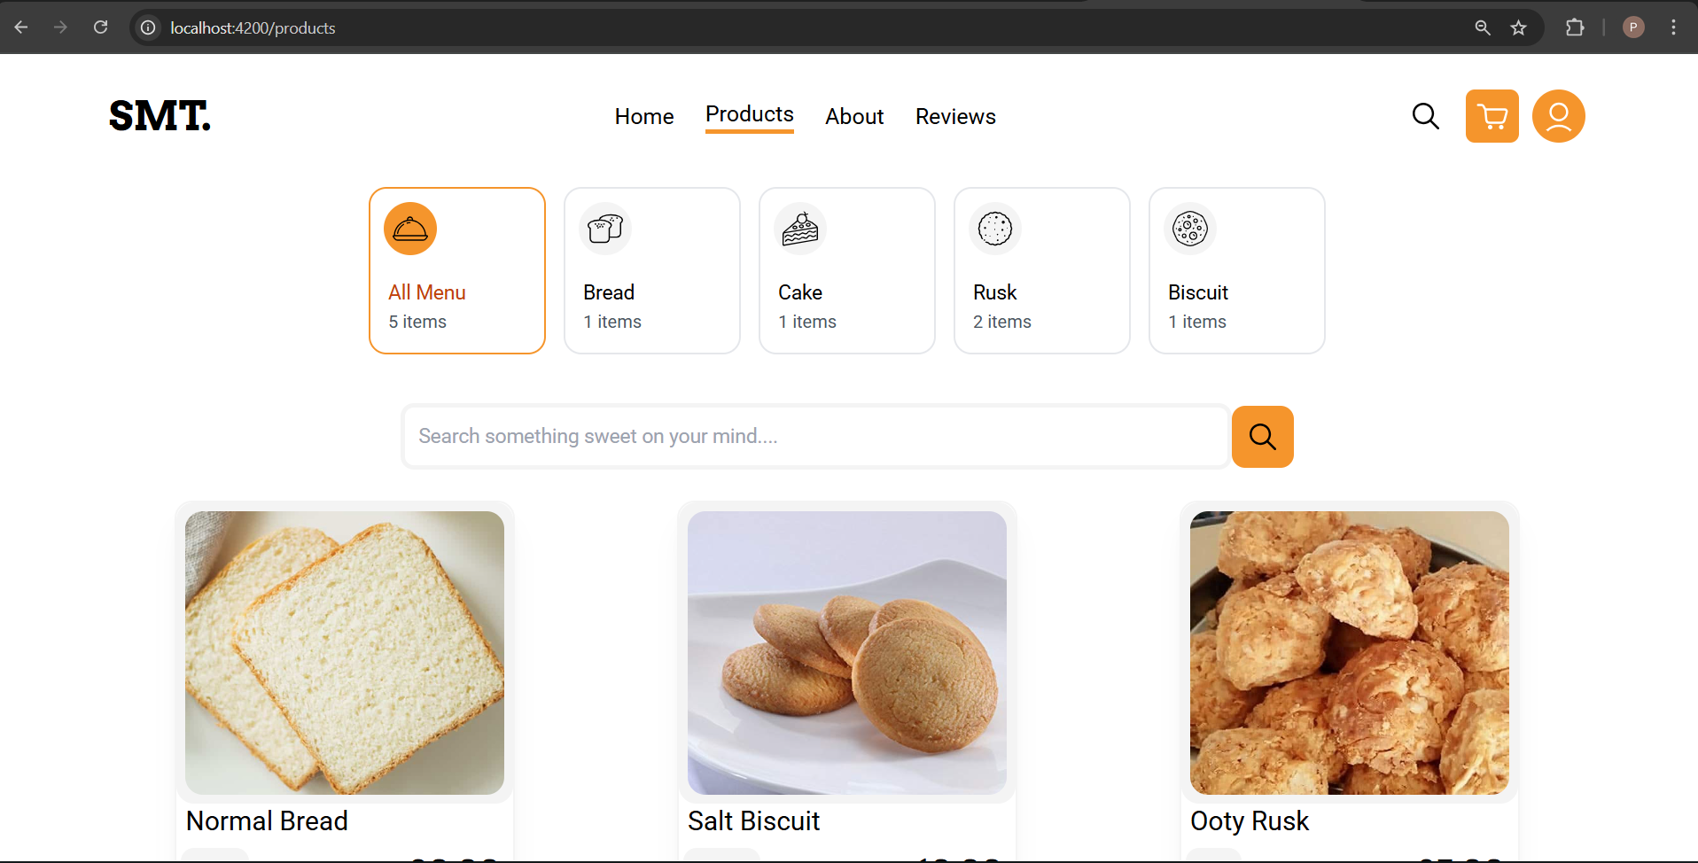Figure A 2.2 Product Page

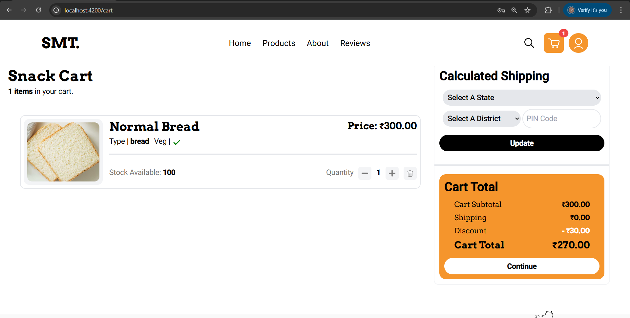

Figure A 2.3 Cart Page

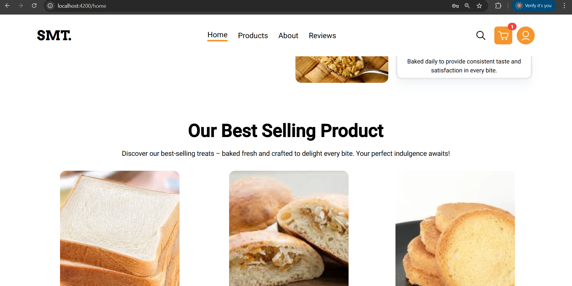

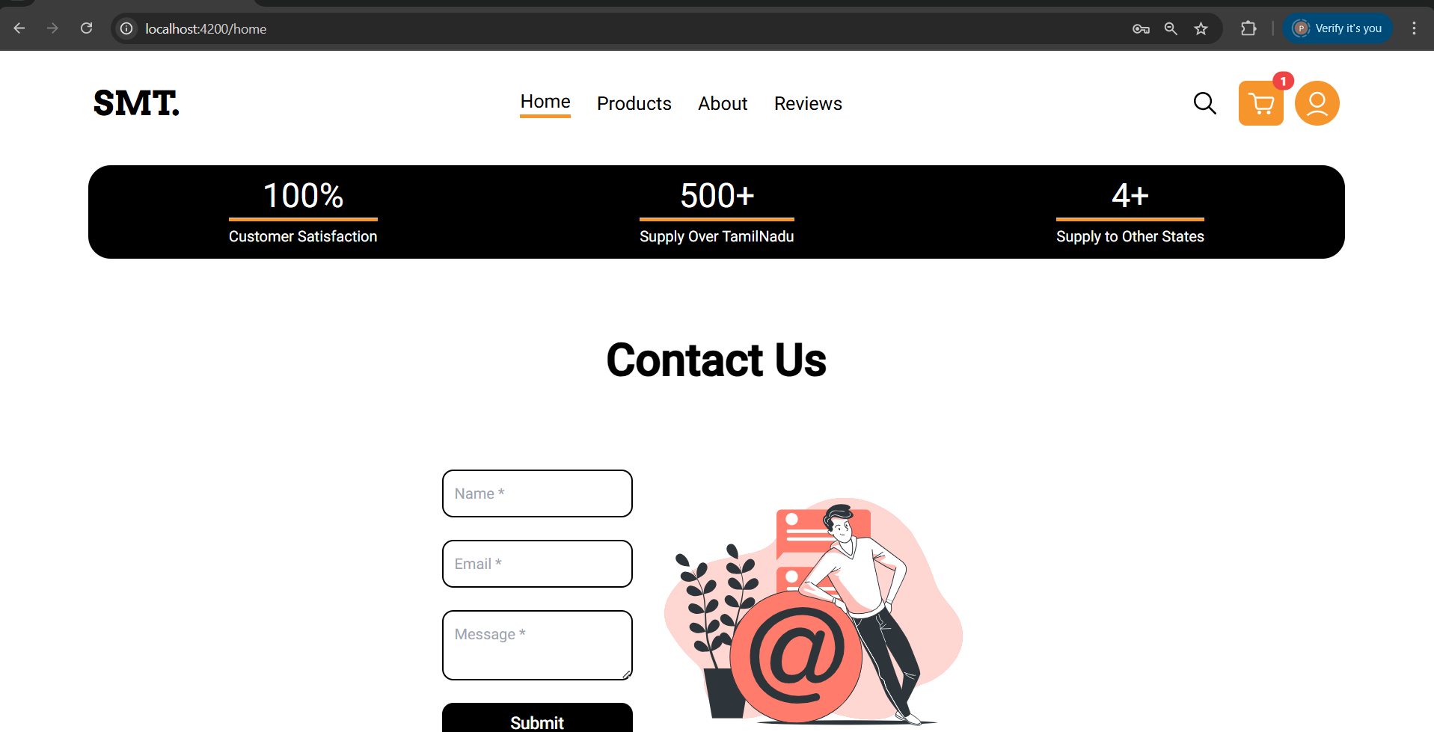

Figure A 2.4 Home Page

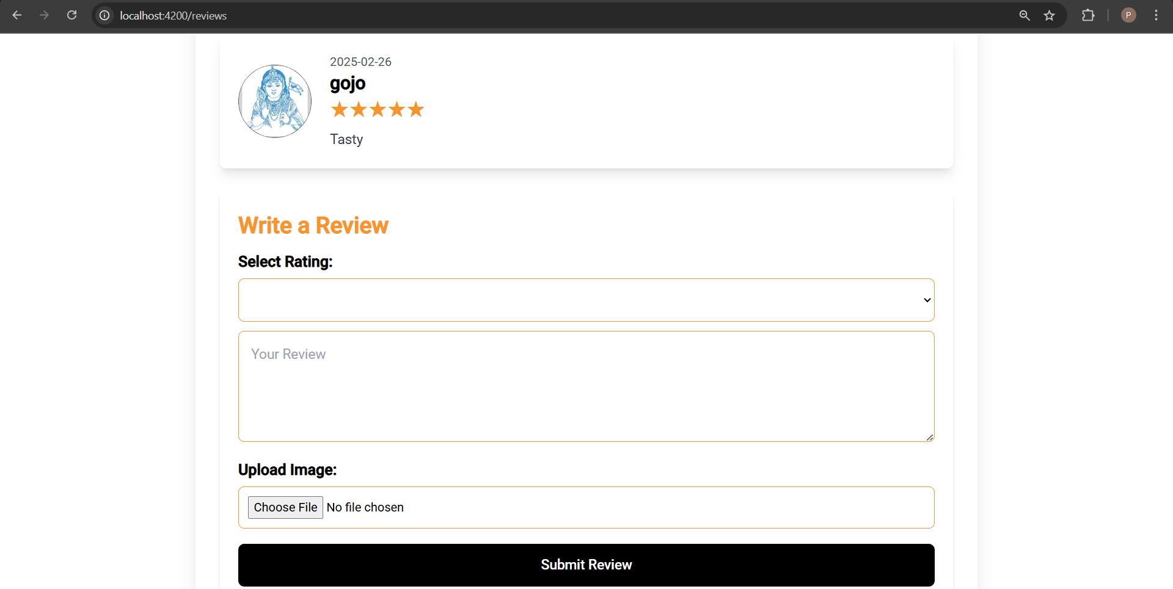

Figure A 2.5 Review Page

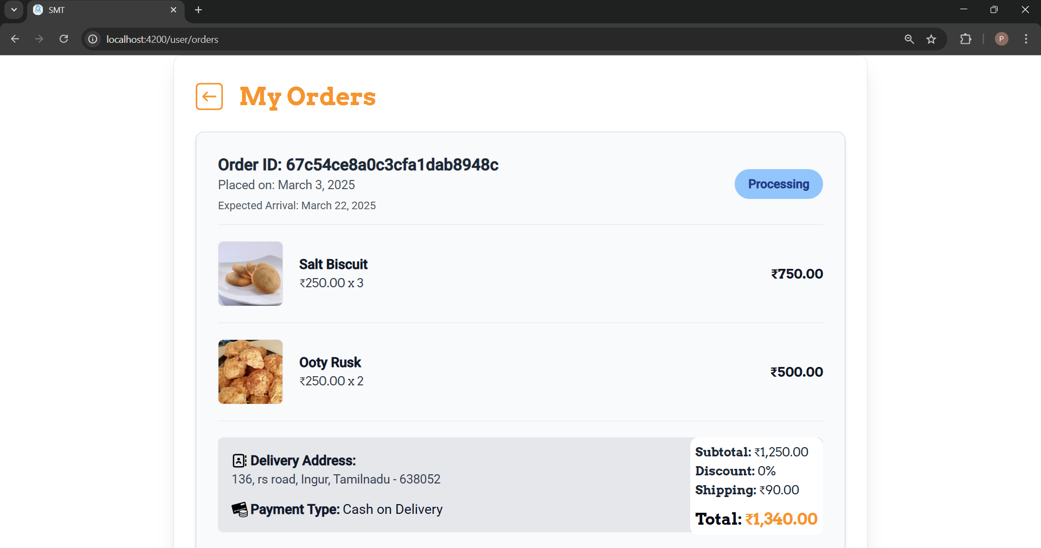

Figure A 2.6 Order Page

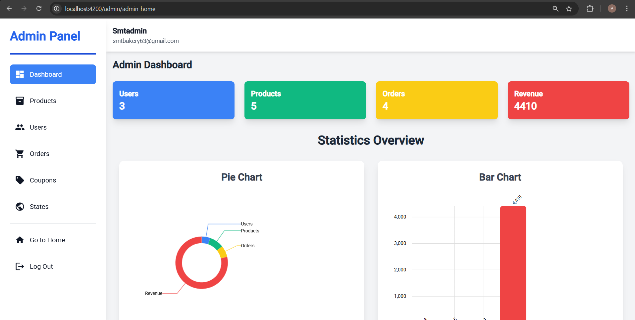

Figure A 2.7 Admin Page

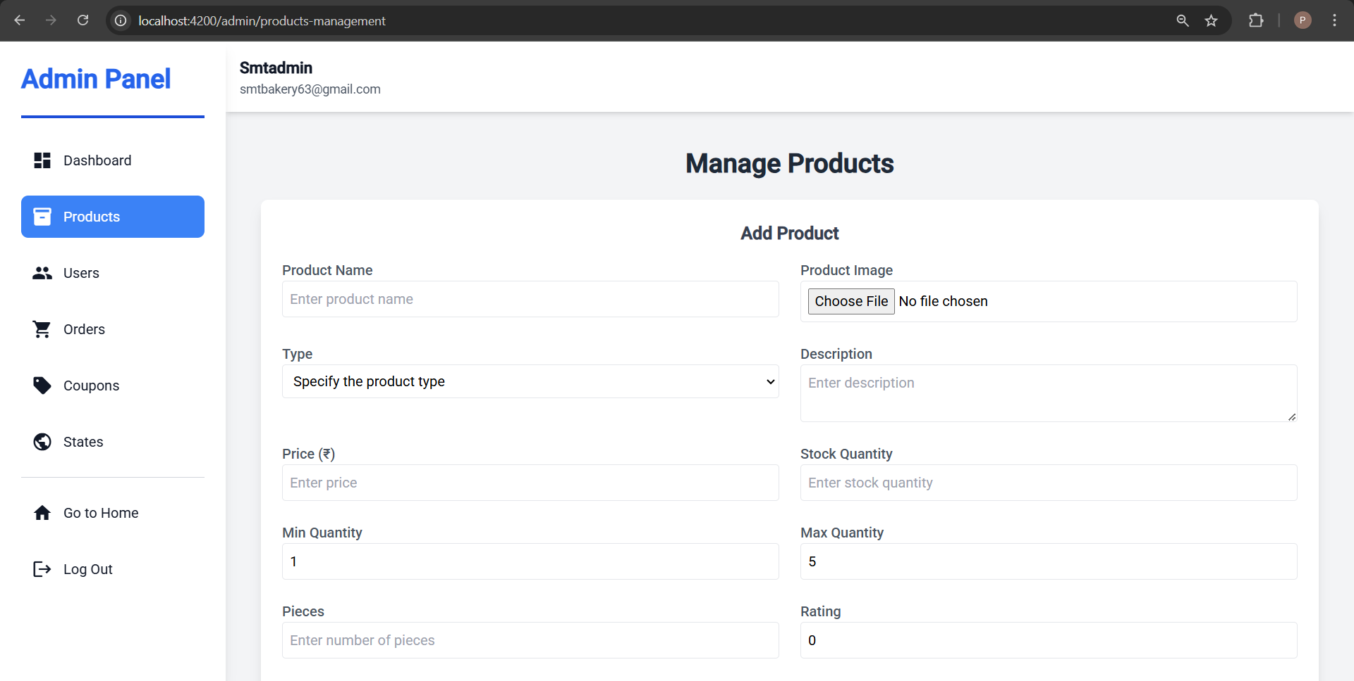

Figure A 2.8 Manage Product Page

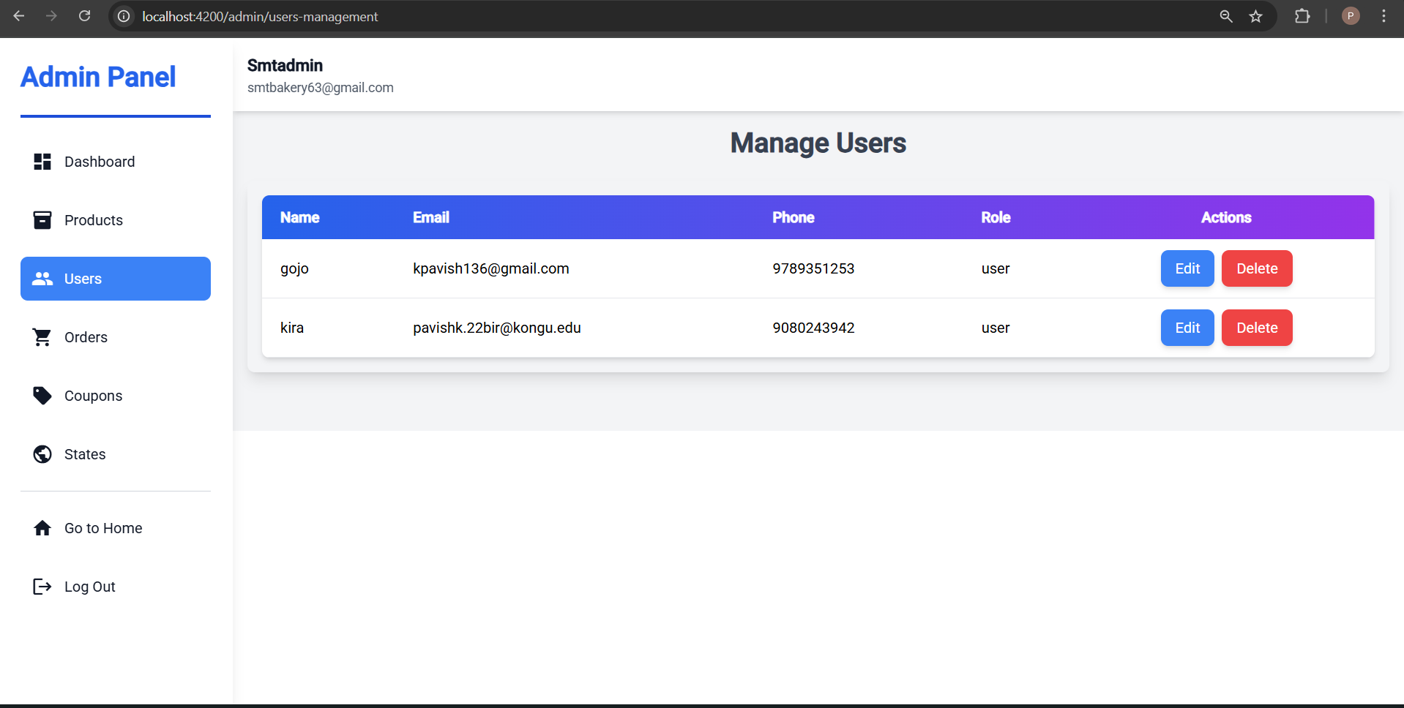

Figure A 2.9 Manage Users Page

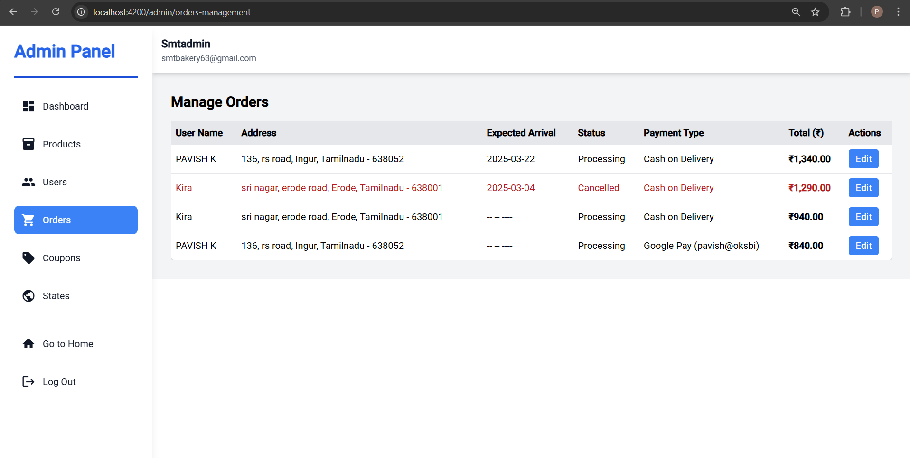

Figure A 2.10 Manage Order Page

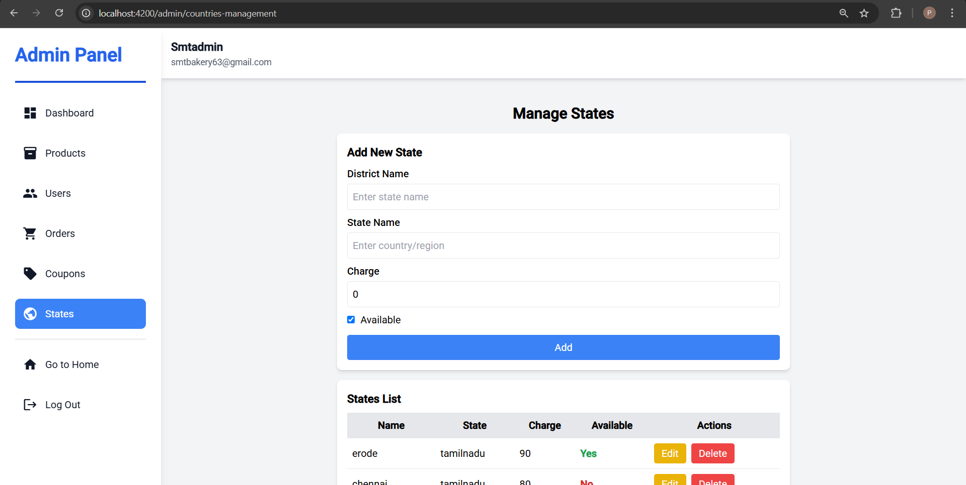

Figure A 2.11 Manage State Page

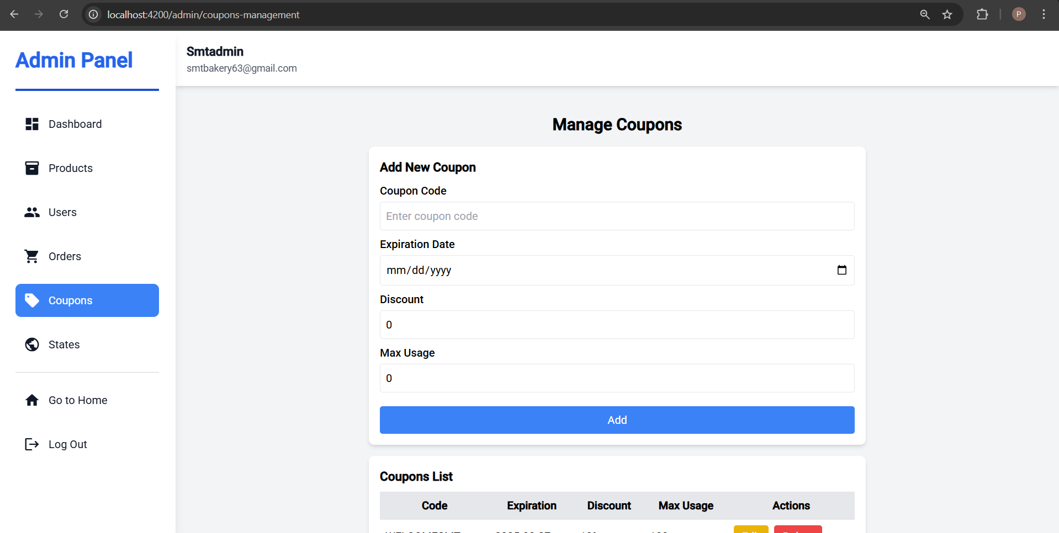

Figure A 2.12 Manage Coupon Page

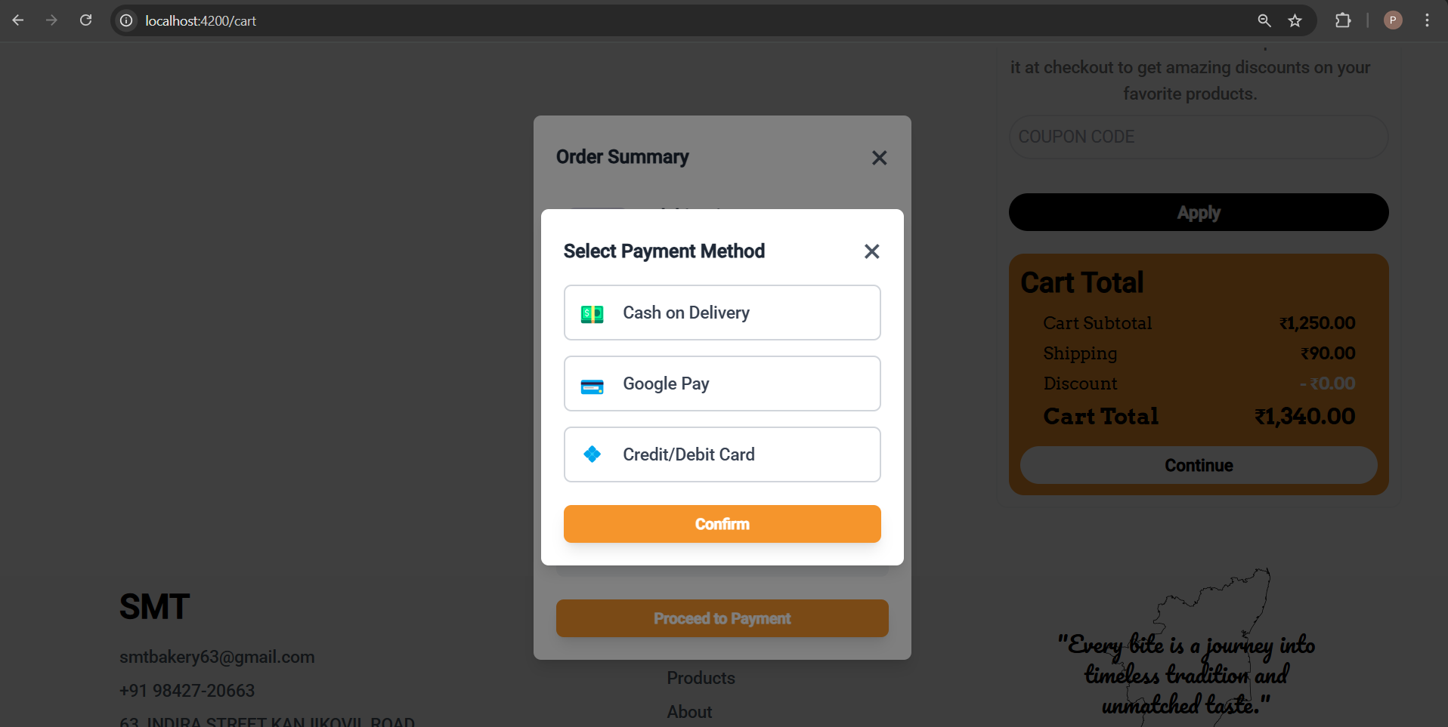

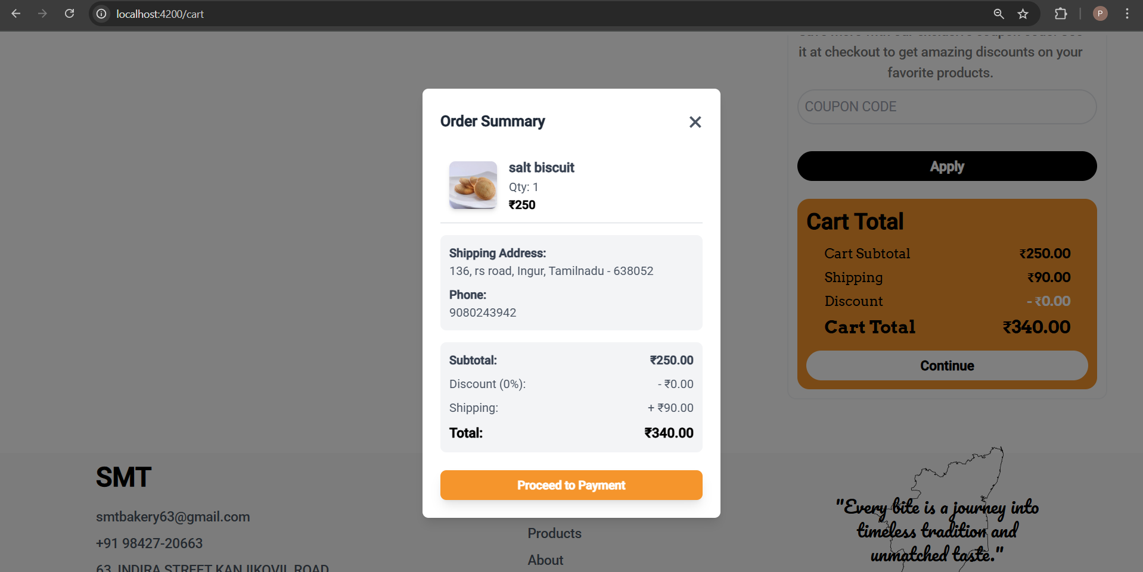

Figure A 2.13 Payment Page